TECHNICAL UNIVERSITY OF CLUJ-NAPOCA
FACULTY OF INDUSTRIAL ENGINEERING, ROBOTICS AND MANAGEMENT OF PRODUCTION
DEPARTMENT OF DESIGN ENGINEERING AND ROBOTICS

ROBOTICS

BACHELOR THESIS

GRADUATE
[NAME AND SURNAME (TNR 12 Bold, UPPERCASE)]

2026

TECHNICAL UNIVERSITY OF CLUJ-NAPOCA
FACULTY OF INDUSTRIAL ENGINEERING, ROBOTICS AND MANAGEMENT OF PRODUCTION
DEPARTMENT OF DESIGN ENGINEERING AND ROBOTICS

ROBOTICS

[GRADUATE’S NAME AND SURNAME (TNR 12 Bold, UPPERCASE)]

[TITLE OF THE DIPLOMA PROJECT
(TNR 14 Bold, UPPERCASE)]

Scientific coordinator

[academic titles (TNR 12 pt Bold, lowercase) coordinator’s first and last name (TNR 12 pt, Bold, UPPERCASE)]

Declaration of Responsibility Regarding
the authenticity of the bachelor's Thesis

I, the undersigned,
_____________________________________________________,
identified with _________ series _____ no. _________________________ (according to the copy attached to this declaration, signed by me), author of the thesis entitled:
_______________________________________________________________________________________________________________________________________________________________
prepared for the purpose of taking the Bachelor's Degree Final Examination at the Faculty of Industrial Engineering, Robotics and Production Management, specialization Robotics, within the Technical University of Cluj-Napoca, during the ______________ session of the academic year hereby declare under my own responsibility that this thesis is the result of my own intellectual work, based on my research and on information obtained from sources that have been duly cited both in the text of the thesis and in the bibliography.
I declare that this thesis contains no plagiarized material and that all bibliographic sources have been used in compliance with Romanian legislation and international copyright conventions.
I further declare that this thesis has not previously been submitted before any other bachelor’s degree Examination Committee.
Should any of the above statements be found to be false at a later date, I understand and accept the applicable administrative sanctions, including the invalidation of the bachelor’s degree Examination.
I also declare and agree that, throughout my lifetime, should it become necessary and desirable to verify the authenticity of my thesis, I may be identified and verified based on the data provided by me and in accordance with the copy of the identity document mentioned above.

Date  ______________ | Signature  __________________

Declaration of Conformity

I, the undersigned,
___________________________________________________ graduate of the Faculty of Industrial Engineering, Robotics and Production Management of the Technical University of Cluj-Napoca, Class of _____________, Bachelor's Degree Program, hereby declare under my own responsibility that the digital copy of my graduation thesis submitted for plagiarism verification is identical to the printed copy of the thesis.

Date  ______________ | Signature  __________________

Appendix 3

TECHNICAL UNIVERSITY OF CLUJ-NAPOCA
Faculty of Industrial Engineering, Robotics and Production Management
Department: Design Engineering and Robotics

Approved,
HEAD OF DEPARTMENT

BACHELOR'S THESIS

Graduate:
Specialization:
Class of:
Proposed topic:
Topic proposed by: a) faculty;
b) commercial company;
c) research and design institute;
d) other situations.
Brief description of the current state of the topic (approx. 50-60 words)

Originality of the topic: a) first-time approach;
b) improvement of an existing solution;
c) previously assigned for a bachelor’s degree Examination;
d) patent;
e) other situations, specify
Relevance and timeliness of solving the topic (approx. 20-30 words)

Date of topic assignment:
Place of documentation/research:
Scientific coordinator:
Consultants:
Date of thesis defense:

Note: The graduate must justify the extent of their own contribution to the thesis.

Scientific coordinator’s signature, Graduate’s signature,

Appendix 4

TECHNICAL UNIVERSITY OF CLUJ-NAPOCA
Faculty of Industrial Engineering, Robotics and Production Management
Department: Design Engineering and Robotics

THESIS EVALUATION FORM
for the bachelor’s Thesis

Graduate:
Specialization:
Class of:
Thesis topic:
Consistency between the thesis title and content: | a) Very Good | b) Good | c) Average | d) Poor | e) Very Poor
Correctness of the proposed solutions: | a) Very Good | b) Good | c) Average | d) Poor | e) Very Poor
Correct use of bibliographic sources: | a) Very Good | b) Good | c) Average | d) Poor | e) Very Poor
Consistency and progress in thesis preparation: | a) Very Good | b) Good | c) Average | d) Poor | e) Very Poor
Scientific level of the thesis: | a) High | b) Medium | c) Low
Quality of the prepared documentation: | a) Very Good | b) Good | c) Average | d) Poor | e) Very Poor
Practical implementation/software development: | a) Yes | b) No
Originality of the proposed solutions (brief description)

Use of computer technology in: a) writing/editing; b) design/development; c) other
Applicability of the thesis: a) commercial companies; b) universities/research institutions; c) no immediate applicability; d) other situations

The graduate's contribution to the overall thesis is: a) 0 - 25 %; b) 25 - 50%; c) 50 - 75%; d) 75 - 100%.

Decision of the scientific coordinator after reviewing the thesis: a) Acceptance b) Revision required c) Rejection.

Scientific coordinator’s signature, Graduate’s signature,
Date: Date:

CONTENTS

Please respect the required format. In the second part further chapters, subchapters and sections can be added, according to your work.

Acknowledgements …….………………………………………………………………… |  |  | XX
Bachelor thesis abstract ………......……………………..……….………………….….… |  |  | XX
General objective and specific objectives.……………...………………………………… |  |  | XX
Part I: General aspects in the context of the theme ……………………… |  |  | YY
1. Introduction ...…………………………………………………………………….…... |  |  | XX
 | 1.1. Basic elements in the context of the project theme …….……........................... |  | xx
 | 1.2. Highlights of technological developments in the project theme area ...………. |  | xx
2. Project planning ……….…………………………………………………………….... |  |  | XX
 | 2.1. Problem to solve …...….…………………………………................................ |  | xx
 | 2.2. Methodology ……….………………….……………………………………… |  | xx
 |  | 2.2.1. Direction of study …………………………………………………….… | xx
 |  | 2.2.2. Theories, methods and instruments used ….………….………………… | xx
 |  | 2.2.3. Technologies, experiments, tests used……... ………...………………… | xx
Part II: Contributions at the project theme ...…………………………… |  |  | YY
3. Chapter 3 (contributions) ………………………………. |  |  | XX
 | 3.1. Subchapter ………………….…………… |  | xx
 |  | 3.1.1. Section …………………………… | xx
 |  | 3.1.2. Section ………….………….……… | xx
 |  | …… | xx
 | 3.2. Subchapter ………………….…………… |  | xx
 |  | 3.2.1. Section …………………………… | xx
 |  | 3.2.2. Section ………….………….……… | xx
 |  | …… | xx
4. Chapter 4 (contributions) ………………………………. |  |  | XX
 | 4.1. Subchapter ………………….…………… |  | xx
 |  | 4.1.1. Section …………………………… | xx
 |  | 4.1.2. Section ………….………….……… | xx
 |  | …… | xx
 | 4.2. Subchapter ………………….…………… |  | xx
 |  | 4.2.1. Section …………………………… | xx
 |  | 4.4.2. Section ………….………….……… | xx
 |  | …… | xx
Synthesis of the major challenges of the project ….………………..……….……….... |  |  | XX
Conclusions ……………...…………………………………………………….……….… |  |  | XX
Bibliography………………...……………………………………………………………. |  |  | XX
Annexes (if necessary) ….………………………………….……………………………. |  |  | XX
 | Annex 1: title ………………….…………… |  | xx
 | Annex 2: title ………………….…………… |  | xx
 | …… |  | xx
Drawings (if necessary) ….……………...…………………………………………......... |  |  | XX
 | Drawing 1: title ………………….…………… |  | xx
 | Drawing 2: title ………………….…………… |  | xx
 | …… |  | xx
CD with the project in electronic format ….…………………………………………... |  |  | XX

ACKNOWLEDGEMENTS

The section is allotted to thank the people and organizations that supported you in successfully completing the work. Please be specific. Do not exceed a page.

[Write here, TNR 12; line spacing: single; alignment: justify]

BACHELOR THESIS ABSTRACT

Please follow the guidelines bellow. Do not exceed two pages for editing the abstract.

The purpose of the proposed theme [What are the reasons for choosing the theme?]

[Write here, TNR 12; line spacing: single; alignment: justify]

General objective [What results did you wanted to obtain through the project theme in general terms?]

[Write here, TNR 12; line spacing: single; alignment: justify]

Specific objectives [Which are the main directions that you acted within the work to get the general objective and why?]

[Write here, TNR 12; line spacing: single; alignment: justify]

Methodology/Approach/Design [What methods, instruments, technologies, concepts, theories and so on did you used to get the proposed objectives within the theme?]

[Write here, TNR 12; line spacing: single; alignment: justify]

Main results [What are the main results you have reached? What contributions have you brought to various issues related to knowledge, innovation, technological development? What major conclusions have you reached?]

[Write here, TNR 12; line spacing: single; alignment: justify]

Results limitations (if it can be applied) [What was the area of ​​study and development at which the topic was limited and what proposals do you have for future developments?]

[Write here, TNR 12; line spacing: single; alignment: justify]

Practical implications (if it can be applied) [What technical and technological implications and impact could the results of your theme have if it were applied in practice? What economic or commercial impact could the eventual application of the results of the topic eventually have?]

[Write here, TNR 12; line spacing: single; alignment: justify]

Other implications (e.g. social, scientific: if it can be applied) [What impact on the environment or aspects of social responsibility might have the results of the topic? How could it affect the quality of life?]

[Write here, TNR 12; line spacing: single; alignment: justify]

Originality/value [What brings your work into the field? What is the value of the results and who could use them predominantly?]

[Write here, TNR 12; line spacing: single; alignment: justify]

Chapters abstract [Please briefly describe each chapter of the license work. Do not exceed two pages for this section.]

[Write here, TNR 12; line spacing: single; alignment: justify]

GENERAL OBJECTIVE AND SPECIFIC OBJECTIVES

The general objective should express in general terms what you want to achieve through the project theme. The general objective must be related to the problem you want to solve (see section 2.1 of the project). Define the general objective so that it is clearly directed to the major problem to solve within the project, be measurable, be realistic. Up to one page for general goal description.
The specific objectives address the various aspects of the problem solved through the project theme. The specific objectives should specify what you are going to do within the project, where and with what purpose. Formulate specific objectives to be measurable. Associate at least one indicator that can measure the degree of resolution of each specific goal. Maximum one page for describing specific goals.

[Write here; TNR 12, line spacing: single; alignment: justify]

Part I

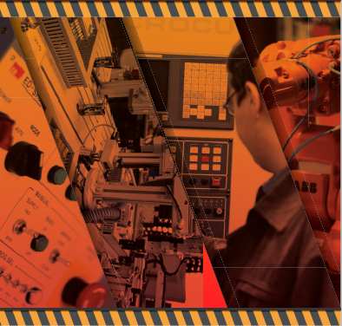

General aspects in the context of the theme

1. INTRODUCTION

1.1. Basic elements in context of the project theme
[A brief description of the project theme is made so that the reader gets familiar with the theme. Bibliographic references are used in this respect. Up to five pages are allocated for this topic]

[Write here; TNR 12, line spacing: single; alignment: justify]

Drafting rules for the project:

These rules are applied for writing all chapters in Part I and Part II of the paper. The text is written with [TNR 12]. Any paragraph starts with [1 Enter]. After the title of the chapter, enter [1 Enter TNR 12]. After the title of the subchapter enter [1 Enter TNR 12]. After the section title, enter [1 Enter TNR 12]. The title of the subchapter is TNR 14, Bold. Section title is TNR 12, Bold.

Figures and tables are required either at the top of the page or at the bottom of the page. The text inside the figures and the tables will be TNR 10 or TNR 11. The text in the title of the figures and tables is TNR 11. Figures must be of very good graphic quality to provide a readable print. Any figure reproduced from bibliographic references should mention in parentheses the source of origin (e.g., processing after (Brad, 2008), taking without changes from (Ionescu, 2009) etc.). The numbering of figures and tables is as follows: the first number indicates the chapter, the second number indicates the order of appearance of the figure or table in the chapter (e.g. Figure 1.1, Figure 1.2, ..., Figure 2.1, ..., Table 1.1, ...). Tables and figures should usually be centered on the page. Multiple figures are accepted on the same row.

Figure 1.1. Figure title.

Figure 1.2. Figure title. Figure 1.3. Figure title.

Table 1.1. Table title.
Table heather | 1 | 2 | 3 | 4

Before or after any figure or table a space of TNR 12 is left. The tables are edited in such a way that they completely cover the left-right space without going out of the edges. Any figure or table must also be mentioned in the text of the written material. The referral is as follows: ex. according to Figure 1.2 (it is wrong to write Figure 1.2) according to Table 1.2 (it is wrong to write Table 1.2).

To exemplify the way we write mathematical relationships we have:

, (1.1)

where: V is ..., Q is .... Mathematical relations are written with TNR 12 Italic, centred. Leave a space of TRN 12 before and after writing the mathematical relationship. If the mathematical relations continue with numerical values, the unit of measurement must be passed at the end. It is mandatory for all terms within a mathematical relationship to state in the relationship or in the associated explanatory text which units of measurement are used. It is also mandatory for each term (symbol) within a mathematical relationship to be given its meaning.

All the papers or sources of information presented in the "Bibliography" should be mentioned in the text of the paper, where the source is used (the respective sources). The way of quoting a work in the text is as follows: a) the name of the first author and the year of the work; b) If a first author has several works in the same year, an alphabet letter is added after year to make the necessary distinction. Examples of citations: (Ionescu, 2000) or (Popescu, 1998; Ionescu, 2000; Brad, 2009) or (***, 2008) or (Georgescu, 2001a) For works or materials that have no clearly defined or known authors, the citation is *** instead of the name of the first author.

1.2. Highlights of technological developments in the project theme area
[A brief description of the technological developments in the field of the project theme at international level is made. Bibliographic references are used in this respect. Up to five pages are allocated for this topic]

[Write here; TNR 12, line spacing: single; alignment: justify]

2. PROJECT PLANNING

2.1. Problem to solve
[It is clear and concise the problem that is to be addressed / solved within the project. The issue must be in line with the overall objective and objectives. Up to two pages are allocated for this topic.]

[Write here; TNR 12, line spacing: single; alignment: justify]

2.2. Methodology

2.2.1. Directions of study
[There are brief and concise steps to follow in solving the problem. The reader needs to understand where it starts, how to go about and where the problem-solving ends. Sketches, diagrams, explanatory graphs can be used. However, explanatory text should also be included. Up to three pages are allocated to this section.]

[Write here; TNR 12, line spacing: single; alignment: justify]

2.2.2. Used theories, methods and instruments
[It briefly explains the theoretical aspects, methods or any other mathematical or other tools used to solve the problem. Please summarize these issues. Avoid copying texts from bibliographic sources that are not useful anyway; preferably refer to the bibliographic source instead of downloading extensive texts from the source. The purpose of this section is to inform, not to "train." Less than half a page is allocated to describe each theory, method, or instrument used.]

[Write here; TNR 12, line spacing: single; alignment: justify]

2.2.3. Technologies, experiments, testes
[It briefly explains what the technologies are used in the project - software, equipment, installations, etc. If some experiments or tests are done, these are briefly presented, and details will be given in part II of the paper. The purpose of this section is to inform, not to "train." Up to half a page is allocated to describe each technology, experiment, or test used. For details, reference is made to bibliographic sources.]

[Write here; TNR 12, line spacing: single; alignment: justify]

Part II

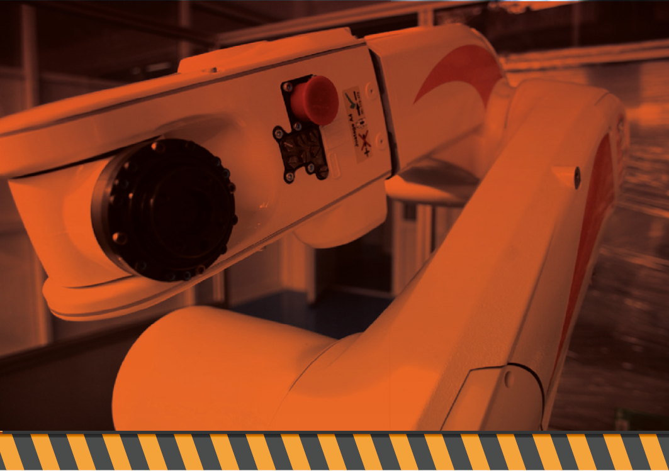

Contributions to the project theme

3. CHAPTER ZZZZZ

3.1. Subchapter ZZZZ
[Use Times New Roman, size 12, single line spacing and justified alignment]
The second part of this paper should delineate the student's contributions towards the chosen project topic. Though there's no specific constraint on the chapter structure, this segment must not exceed 70 pages. Importantly, conclusions, appendices, and plans are not included in this page count.
Appendices should comprise of items such as: source code listings, graphs, expansive tables of experimental results, complex calculations, and copies of scientific papers authored by the student and published in relevant field journals or conferences.
Drawings should include both 2D and 3D sketches that are larger than A4 in size.
The CD-ROM must contain the entirety of the project in electronic format, including movies, source and executable files (where applicable).
To achieve high scores on the evaluation criteria (refer to page 5), it is recommended to structure the information meticulously.
3.X. Main Mechanical Components Calculation
Irrespective of the project's theme, this chapter is essential. Consult with the project manager to select the mechanical components to be dimensioned. The objective of this chapter is to showcase the student's basic understanding in the field of design. While the project's core may not involve mechanical components, students can take a creative approach to align with this requirement. For instance, they could discuss and analyze the hardware components necessary for the operation of their software system or they can imagine that some parts of the hardware that interact with the software are broken, and they have to replace them.
3.Y. Driving System Calculation
This chapter, which is mandatory for all project themes, might encompass electrical, pneumatic, hydraulic or combination systems, depending on the project's specifics. The goal is to demonstrate your foundational knowledge in driving systems. While the project's core may not involve driving systems, students must be creative and imagine how their system is integrated into a larger system that uses drivers. And they can apply the request of this section for that case.
3.Z. Technological Calculations for a Mechanical Component
Every project theme must include this chapter. Discuss with the project leader about the choice of the mechanical reference, for which the datasheet is to be developed. This chapter aims to prove your rudimentary skills in manufacturing. See the indications above for the case your project does not include hardware / mechanical components. You must consider a component from a super-system where your project can be integrated.
3.U. Geometric Parameters and Tolerances for a Mechanical Component
This mandatory chapter requires a discussion with the project leader about the chosen mechanical reference. The intent is to create a drawing that outlines geometric parameters, dimensional tolerances, and other manufacturing conditions. This chapter's purpose is to evidence your foundational skills in detailed design.
3.V. Automation, Electronics, and Sensorics
This chapter is only required if the project involves automation-related aspects such as controllers, microcontrollers, PLCs, sensors, etc. It should detail functional diagrams, design calculations, and component selection processes while explaining system operations.
3.Q. Programming
This chapter, only necessary if the project theme involves programming aspects, should include pseudo-code, source code, and logic diagrams as applicable.
3.W. Comprehensive Drawings
Regardless of the project's theme, this chapter must be included. It should feature a 2D solution drawing on A1 or A0 format paper, accompanied by a components table. Please note, automatic 2D drawing generation from the 3D model via CAD systems may result in certain omissions.

SUMMARY OF THE FIRST THREE MAJOR CHALLENGES OF THE PROJECT

There are three of the most complex technical, scientific or other issues that you had to solve within the project to reach the proposed objectives. Practically, you are asked to extract some of the project's second part of the project and present it in a condensed form to better highlight (to make it more visible) the issues of originality, innovation, complexity of the project. In other words, you must present those elements that "best sell" the project (Note: Unique Selling Points). Up to three pages are allocated for this chapter.

The first major challenge

[Write here; TNR 12, line spacing: single; alignment: justify]

The second major challenge

[Write here; TNR 12, line spacing: single; alignment: justify]

The third major challenge

[Write here; TNR 12, line spacing: single; alignment: justify]

CONCLUSIONS

Describe the results obtained, discuss the results, present the limitations of the results, present where the results are to be integrated, what future intentions exist towards the development of the project theme. The conclusions should summarize the entire work and highlight the points that support the quality of work and the results obtained. Conclusions must demonstrate to the reader why this work is important. Conclusions must give the feeling of completeness (the goals have been achieved). The conclusions are a synthesis, not a summary of what you did in the paper. Up to two pages are allocated for this chapter.

[Write here; TNR 12, line spacing: single; alignment: justify]

BIBLIOGRAPHY

Follow the format of the bibliographic references.

- Acur, N., Englyst, L. (2012), Assessment of Strategy Formulation: How to Ensure Quality in Process and Outcome, International Journal of Operations & Production Management, vol. 26, nr. 5, pg. 69-91.
- Alexis, J. (2008), Metoda Taguchi în Practica Industrială. Planuri de Experienţe, Ed. Tehnică, Bucureşti.
- Allegra, M., Fulantelli, G. (2017), ICT for SMEs: Some Key Elements to Improve Competitiveness, Proceeding of the 2nd International Conference on the Management of Technological Changes, Ed. Economică, Bucureşti, pg. 377-388.
- Heylighen, F., Pop, I, Mann, T. (2015), Building a Science of Complexity, www.pespmc1. vub.ac.be/papers/BuildingComplexity.html, descărcat de pe internet la 30.03.2016.
- *** (2009), SR EN ISO 9001. Sisteme de Management al Calităţii. Cerinţe, ASRO.
- *** (2011a), Concept to Customer. A Roadmap for the Integrating Leading DFSS Methods, www.c2c-solutions.com, descărcat de pe internet la 23.05.2016.
Above are examples of writing bibliographic references for different situations. Please strictly follow these requirements. The references are in alphabetical order after the name of the first author, then after the year of appearance if there are several works of the same author. References without author (***) are written at the end of the list.

Declaration of Originality from the Scientific Coordinator
I, [Title, First Name, Last Name], the scientific coordinator, hereby affirm the authenticity and originality of the Bachelor's thesis entitled:
"[Title of the Bachelor's Thesis]"
Authored by: [First Name, Last Name]
I hereby certify, to the best of my knowledge, that the contributions and findings presented in this work are the original work of the aforementioned student and do not contain any copied content or represent the contributions of any individual other than the named student.
Additional Remarks (if applicable):

Date:
(Signature of the scientific coordinator)

The framing of bachelor thesis in the specialized field or related fields

Please enter in the appropriate box the letter P for the main subdomain under which the license work falls (one main sub-domain is selected) and the letter C for the complementary subdomains (if applicable, you can choose several complementary subdomains).

Domain of expertise
Robotics programming |  |  | Action of robotic systems
Interfaces human-robot |  |  | Managing the supply chain for robotic production
Tele-service and tele-monitoring in robotics |  |  | Robotic systems command and control
Virtual reality in robotics |  |  | Information management in robotic systems
Process optimisation in robotics manufacturing processes |  |  | Manufacturing intelligent systems
Advanced mechanics in robotics |  |  | Robotics optimisation
Robotics modelling and simulation |  |  | High precision robotic systems
Planning of robotic/automated production |  |  | Mini and micro-robotics
Client-server applications in robotics |  |  | Flexible manufacturing systems
Quality assurance in automated processes |  |  | Robotics mechanical design
Autonomous robotic systems |  |  | Human-robot and multi-robot cooperation applications
Vision systems in robotics |  |  | Other (specify):

Related domains
Manufacturing automation |  |  | Sensorics
Automation |  |  | Medical equipment and devices
Intelligent industrial products |  |  | Intelligent buildings
Industrial automation |  |  | Automated manufacturing technologies
All type of mechatronics modules |  |  | Monitoring and control of processes and technologies
Internet of Things (IoT) |  |  | Production planning systems
Smart consumer products |  |  | Virtual reality and related technologies
Modules in the structure of manufacturing equipment |  |  | Applied electronics
Numerically control manufacturing equipment |  |  | Technologies in physics and chemistry (lasers, holography, etc.)
Drive, servo drives and electric drives |  |  | Non-destructive inspection, measurement, and control systems
Hydraulics and pneumatics |  |  | Any technical or technological innovation
Microcontrollers |  |  | Other (specify):

Assessment of the bachelor thesis by the scientific coordinator

This space is allocated to the scientific coordinator

 | Unsatisfactory | Satisfactory | Good | High | Excellent
Criterium Level | 1 | 2 | 3 | 4 | 5
Quality of expression in Romanian/English
Aesthetic aspect of the bachelor thesis
Subject actuality
Clarity of the written documentation
Originality
Technical quality (fairness solutions, calculations etc.)
Quality of the bibliographic documentation
Quality of the drawings
Relevance for the social or economic environment

Signature of the scientific coordinator: ______________________________

Checklist

Compulsory component | Approached in the bachelor thesis
Compulsory component | YES | NO
Calculation of the main mechanical components
Calculation of the driving system
Technological calculation for a mechanical part
Definition of geometric parameters and tolerances for a mechanical part
Overall drawings
A .mp4 video clip of 60 sec with the presentation of your project (for marketing purposes)

Optional components / considering the specific of the subject | Approached in the bachelor thesis
 | YES | NO
Automation, electronics and sensorics
Programming

Signature of the scientific coordinator: ______________________________

